***Unit-5, Lab-1, Programs-1, 2, 3, 4***

***Program-1.1* WAP to create Alert Dialog with material & Cupertino theme and display it with 1 “Ok” button.**

import 'package:flutter/material.dart';

class AlertDialogDemo extends StatefulWidget {

  @override

  State<AlertDialogDemo> createState() => _AlertDialogDemoState();

}

class _AlertDialogDemoState extends State<AlertDialogDemo> {

  @override

  Widget build(BuildContext context) {

    return Scaffold(

      appBar: AppBar(title: Text("AlertDialogDemo"),),

      body:  Center(

        child: IconButton(

          icon: Icon(Icons.add_alert,size: 50,),

          onPressed: () {

            showDialog(

              context: context,

              builder: (BuildContext context) {

                return AlertDialog(

                  title: Text('Alert Dialog'),

                  content: Text('This is an AlertDialog!'),

                  actions: [

                    ElevatedButton(

                      child: Text('OK'),

                      onPressed: () {

                        Navigator.of(context).pop(); *// Close the AlertDialog*

                      },

                    ),

                  ],

                );

              },

            );

          },

        ),

      ),

    );

  }

}

***OutPut:***

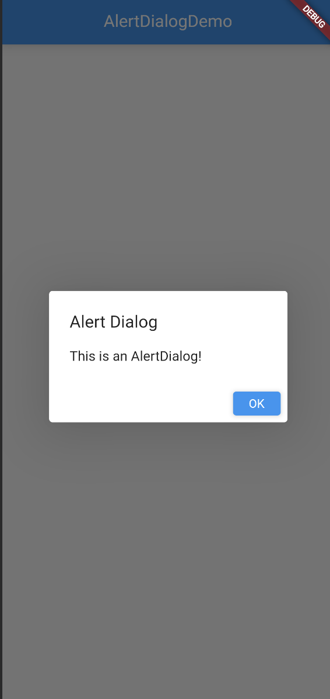

***Program-1.2*** WAP to show DatePickerDialog on button click and set selected date.

import 'package:flutter/material.dart';

class DatePickerDemo extends StatefulWidget {

   @override

  State<DatePickerDemo> createState() => _DatePickerDemoState();

}

class _DatePickerDemoState extends State<DatePickerDemo> {

  DateTime selectedDate = DateTime.now();

  Future<void> _selectDate(BuildContext context) async {

    final DateTime? picked = await showDatePicker(

      context: context,

      initialDate: selectedDate,

      firstDate: DateTime(2000),

      lastDate: DateTime(2101),

    );

    if (picked != null && picked != selectedDate)

      setState(() {

        selectedDate = picked;

      });

  }

  @override

  Widget build(BuildContext context) {

    return Scaffold(

      appBar: AppBar(

        title: Text("Date Picker Example"),

      ),

      body: Center(

        child: Column(

          mainAxisSize: MainAxisSize.min,

          children: <Widget>[

            Text(

              "${selectedDate.toLocal()}".split(' ')[0],

              style: TextStyle(fontSize: 55, fontWeight: FontWeight.bold),

            ),

            SizedBox(

              height: 20.0,

            ),

            ElevatedButton(

              onPressed: () => _selectDate(context),

              child: Text(

                'Select date',

                style: TextStyle(

                  color: Colors.white,

                ),

              ),

            ),

          ],

        ),

      ),

    );

  }

}

**OutPut:**

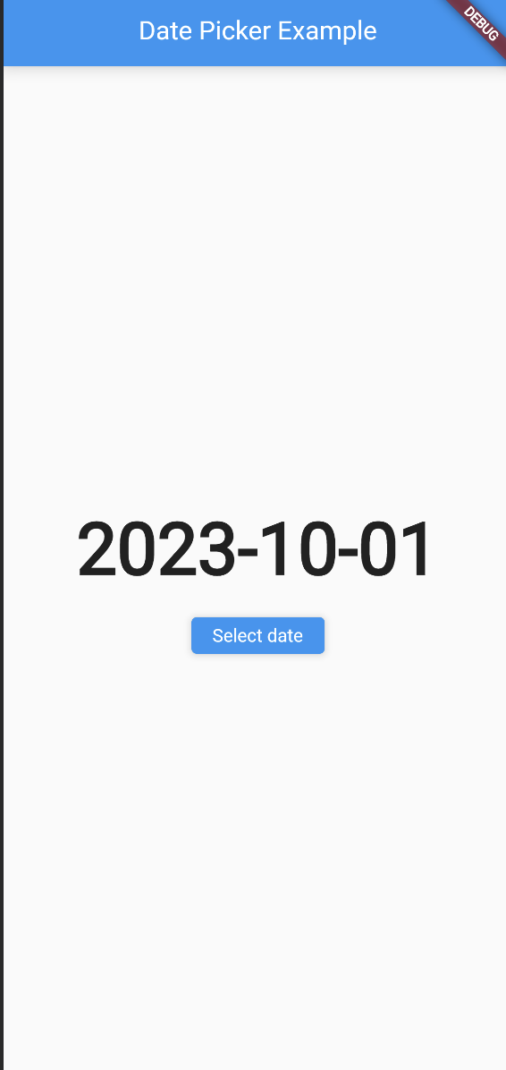 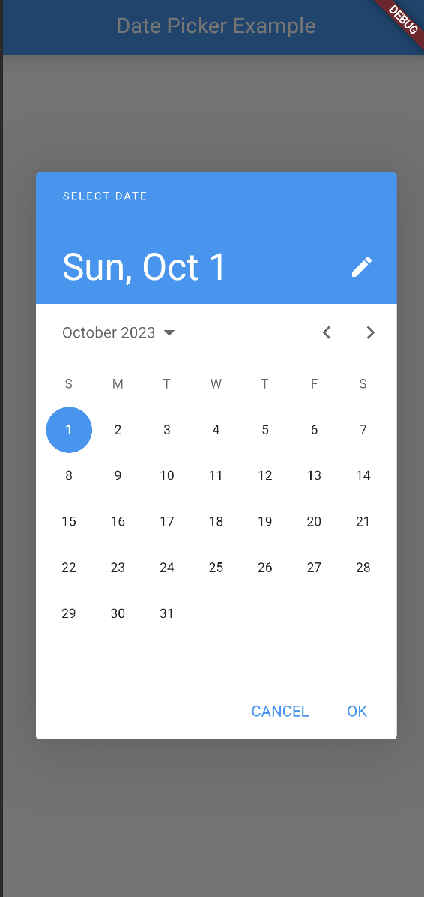

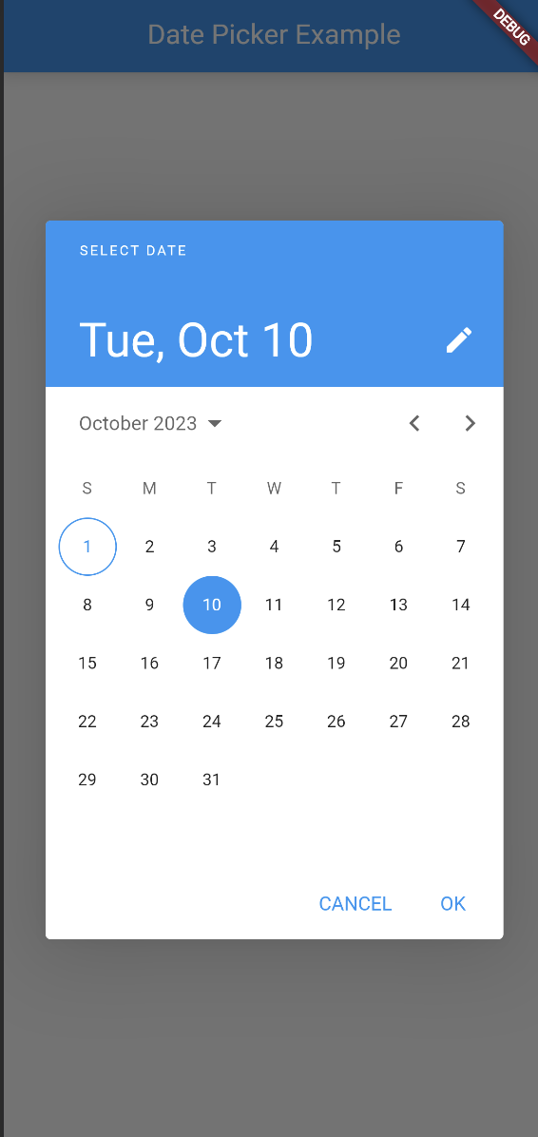 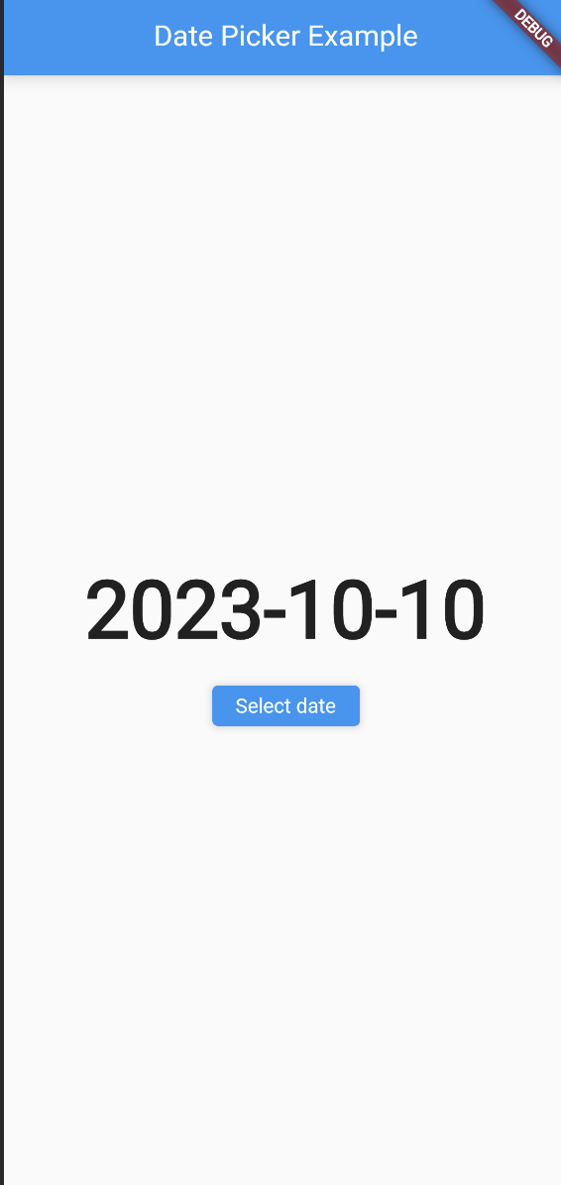

***Program-1.3*** WAP to fetch json file from asset folder & parse json data and display data in widget.

***Program-1.4*** WAP to generate model class from json.

**Json Data File…**

[

  {

    "name": "Krish",

    "age": 20

  },

  {

    "name": "Kishan",

    "age": 25

  },

  {

    "name": "Yash",

    "age": 15

  }

]

import 'dart:convert';

import 'package:flutter/material.dart';

import 'package:flutter/services.dart';

class JsonDataDemo extends StatefulWidget {

  @override

  State<JsonDataDemo> createState() => _JsonDataDemoState();

}

class _JsonDataDemoState extends State<JsonDataDemo> {

  List<Person> persons = [];

  Future<void> loadJsonData() async {

    final String jsonData =

    await rootBundle.loadString('assets/data.json');

    final List<dynamic> jsonList = json.decode(jsonData);

    setState(() {

      persons = jsonList.map((json) => Person.fromJson(json)).toList();

    });

  }

  @override

  void initState() {

*super*.initState();

    loadJsonData();

  }

  @override

  Widget build(BuildContext context) {

    return Scaffold(

      appBar: AppBar(

        title: Text("JSON Data Example"),

      ),

      body: Center(

        child: ListView.builder(

          itemCount: persons.length,

          itemBuilder: (context, index) {

            final person = persons[index];

            return ListTile(

              title: Text("Name: ${person.name}"),

              subtitle: Text("Age: ${person.age.toString()}"),

            );

          },

        ),

      ),

    );

  }

}

class Person {

  final String name;

  final int age;

  Person({required *this*.name, required *this*.age});

  factory Person.fromJson(Map<String, dynamic> json) {

    return Person(

      name: json['name'],

      age: json['age'],

    );

  }

}

***OutPut:***

